

# PROJECT REPORT

On

## MEDITATION

## AND

## MINDFULNESS

## APP

### Department of Computer Engineering & Applications

### GLA UNIVERSITY

**GLA University Mathura- 281406, INDIA**

**2022-2023**

**SUBMITTED BY:- SUBMITTED TO:-**

|  |  |  |
| --- | --- | --- |
| **Ayush Sharma** | **(201500183)** | **Ms. Gurpreet Kaur** |
| **Param Varshney** | **(201500460)** | **(Technical Trainer)** |
| **Umang Sharma**  **Akanksha Tiwari** | **(201500753)**  **(201500054)** |  |

### Declaration

We hereby declare that the work which is being presented in the Project of “**Meditation and MindFulness App”,** in partial fulfilment of the requirements for Project viva voce, is an authentic record of our own work carried by the team members under the supervision of our mentor

|  |
| --- |
| **Ms. Gurpreet Kaur.** |

Group Members :-

|  |  |
| --- | --- |
|  |  |
| **Ayush Sharma** | **(201500183)** |
| **Param Varshney** | **(201500460)** |
| **Umang Sharma**  **Akanksha Tiwari** | **(201500753)**  **(201500054)** |

**Course** : B.Tech (Computer Science and Engineering) Year: 3rd

**Semester** : 5th

**Supervised By:**

Ms. Gurpreet Kaur, Technical Trainer,

GLA University, Department of Computer Engineering & Application

**Department of computer Engineering and Applications**

**GLA University, Mathura**

**17 km. Stone NH#2, Mathura-Delhi Road, P.O. – Chaumuha, Mathura – 281406**

**Certificate**

This is to certify that the above statements made by the candidates are correct to the best of my/our knowledge and belief.

Supervisor Ms. Gurpreet Kaur

Technical Trainer

Dept of CEA, GLA University

Project Mentor Program Coordinator (Ms. Gurpreet Kaur ) (Mr. Subhash Agrawal

# About the Project

A meditation app is a mobile application designed to help users practice meditation and

improve their mental well-being. The app typically includes a variety of guided

meditations, ranging from beginner to advanced levels, and may also include features

such as breathing exercises, mindfulness exercises, and sleep aids.

The purpose of a meditation app is to make meditation more accessible and convenient

for users. It allows users to practice meditation anytime, anywhere, and at their

own pace. Meditation apps also typically include progress tracking and reminders to

help users establish a regular meditation practice.

Using a meditation app has been shown to have numerous benefits, including reducing

stress and anxiety, improving focus and attention, and promoting better sleep. Many apps

offer personalized recommendations based on the user's goals and preferences.

# Motivation

Meditation has been practiced for thousands of years and has become increasingly popular in recent years, as more people recognize the benefits of mindfulness and

stress reduction for improving overall well-being. This project aims to investigate

the impact of a meditation app on mental health outcomes and to explore the

factors that influence users' engagement with the app.

The problem of stress and anxiety has become increasingly prevalent in modern society, and traditional treatments such as medication and therapy can be expensive

and time-consuming. Meditation offers a low-cost, non-invasive alternative for managing stress and improving mental health outcomes. However, many people

find it difficult to establish a regular meditation practice on their own, which is

where a meditation app can be helpful.

**The objectives of this project are to:**

- Assess the impact of a meditation app on mental health outcomes, including

stress, anxiety, and mood.

- Identify the factors that influence users' engagement with the app, including

usability, design, and features.

- Evaluate the effectiveness of personalized recommendations in improving

users' engagement with the app and their meditation practice.

# 

### Requirements

### Software Requirements:

**Languages/Technologies Used :** HTML, CSS, JavaScript, MongoDB, JQuery

**IDE Used**: Vs code

**Web Browser:** Google Chrome

**GitHub:**

GitHub is a code hosting platform for version control and collaboration. It lets you and others work together on projects from anywhere. GitHub Repository: A GitHub repository can be used to store a development project. It can contain folders and any type of files (HTML, CSS, JavaScript, Documents, Data, Images). A GitHub repository should also include a license file and a README file about the project. A GitHub repository can also be used to store ideas, or any resources that you want to share.

### Hardware Requirements:

* + **Processor Required: Intel i3**
  + **Operating System: Windows 10**
  + **RAM: 4GB**
  + **Hardware Devices: Computer System**
  + **Hard Disk: 256GB**

# Acknowledgement

We thank the almighty for giving us the courage and perseverance in completing the project. This project itself is an acknowledgement for all those people who have given us their heartfelt co-operation in making this project a grand success.

We extend our sincere thanks to Ms. Gurpreet Kaur Technical Trainer at “GLA University, Mathura” for providing his valuable guidance at every stage of this project work. We are profoundly grateful towards the unmatched services rendered by him. And last but not least, we would like to express our deep sense of gratitude and earnest thanks giving to our dear parents for their moral support and heartfelt cooperation in doing the project.

### Abstract

Meditation apps have become increasingly popular in recent years as people

seek ways to manage stress and improve their overall well-being. These apps

offer a variety of guided meditations, mindfulness exercises, and relaxation

techniques that can be accessed from anywhere at any time. Here is an

extract for a project report on meditation apps:

Meditation apps have gained significant traction in the health and

wellness industry as people increasingly seek ways to reduce stress and

improve their overall well-being. These apps offer a range of features,

including guided meditations, sleep aids, and breathing exercises, designed

to help users manage their mental health and promote relaxation. The aim

of this project is to explore the effectiveness of meditation apps in

improving mental health and to determine the most popular and

effective meditation apps available on the market.

# Contents

**Acknowledgment…………………………………….........**

**Abstract………………………………………………**

**1.Introduction --------------------------------------------**

**2.Technologies Used:** ------------------------------------------------------- **12**

HTML---------------------------------------------------------------------

CSS --------------------------------------------

JavaScript ----------------------------------

JQuery --------------------------------------------------------

MongoDB -----------------------------------------------------

‘

**List Of Figures………………………………………………………….**

**Conclusion……………………………………………**

**Bibliography………………………………………….**

**Introduction**

Meditation apps have gained significant traction in

the health and wellness industry as people increasingly seek ways to reduce stress and improve their overall well-being. These apps offer a range of features, including guided meditations, sleep aids, and

breathing exercises, designed to help users manage

their mental health and promote relaxation. The aim

of this project is to explore the effectiveness of meditation apps in improving mental health and to determine the most popular and effective meditation apps available on the market.

**Technologies Used**

# HTML

**HTML** stands for **Hyper Text Markup Language**, which is the most widely used language on Web to develop web pages. **HTML** was created by Berners-Lee in late 1991 but "HTML 2.0" was the first standard HTML specification which was published in 1995. HTML 4.01 was a major version of HTML and it was published in late 1999. Though HTML 4.01 version is widely used but currently we are having HTML-5 version which is an extension to HTML 4.01, and this version was published in 2012.

It is used for:

* Web development (server-side),
* Software development.

Here are some of the most common uses for HTML:

* **Web pages development** - HTML is used to create pages which are rendered over the web. Almost every page of web is having html tags in it to render its details in browser.
* **Internet Navigation** - HTML provides tags which are used to navigate from one page to another and is heavily used in internet navigation.
* **Responsive UI** - HTML pages now-a-days works well on all platform, mobile, tabs, desktop or laptops owing to responsive design strategy.
* **Offline support** HTML pages once loaded can be made available offline on the machine without any need of internet.
* **Game development**- HTML5 has native support for rich experience and is now useful in gaming developent arena as well.

# CSS

**CSS** is used to control the style of a web document in a simple and easy way.

**CSS** is the acronym for **"Cascading Style Sheet"**. This tutorial covers both the versions CSS1,CSS2 and CSS3, and gives a complete understanding of CSS, starting from its basics to advanced concepts.

## Applications of CSS

* **CSS saves time** - You can write CSS once and then reuse same sheet in multiple HTML pages. You can define a style for each HTML element and apply it to as many Web pages as you want.
* **Pages load faster** - If you are using CSS, you do not need to write HTML tag attributes every time. Just write one CSS rule of a tag and apply it to all the occurrences of that tag. So less code means faster download times.
* **Easy maintenance** - To make a global change, simply change the style, and all elements in all the web pages will be updated automatically.
* **Superior styles to HTML** - CSS has a much wider array of attributes than HTML, so you can give a far better look to your HTML page in comparison to HTML attributes.
* **Multiple Device Compatibility** - Style sheets allow content to be optimized for more than one type of device. By using the same HTML document, different versions of a website can be presented for handheld devices such as PDAs and cell phones or for printing.
* **Global web standards** - Now HTML attributes are being deprecated and it is being recommended to use CSS. So its a good idea to start using CSS in all the HTML pages to make them compatible to future browsers.

# JavaScript:-

**JavaScript** is a lightweight, interpreted **programming** language. It is designed for creating network-centric applications. It is complimentary to and integrated with Java. **JavaScript** is very easy to implement because it is integrated with HTML. It is open and cross-platform.

.

JavaScript is the most popular **programming language** in the world and that makes it a

programmer’s great choice. Once you learnt Javascript, it helps you developing great front-end as

well as back-end softwares using different Javascript based frameworks like jQuery, Node.JS etc

### Applications of Javascript Programming:-

* **Client side validation** - This is really important to verify any user input before submitting it to the server and Javascript plays an important role in validting those inputs at front-end itself.
* **Manipulating HTML Pages** - Javascript helps in manipulating HTML page on the fly. This helps in adding and deleting any HTML tag very easily using javascript and modify your HTML to change its look and feel based on different devices and requirements.
* **User Notifications** - You can use Javascript to raise dynamic pop-ups on the webpages to give different types of notifications to your website visitors.
* **Back-end Data Loading** - Javascript provides Ajax library which helps in loading back-end data while you are doing some other processing. This really gives an amazing experience to your website visitors.
* **Presentations** - JavaScript also provides the facility of creating presentations which gives website look and feel. JavaScript provides RevealJS and BespokeJS libraries to build a web-based slide presentations.
* **Server Applications** - Node JS is built on Chrome's Javascript runtime for building fast and scalable network applications. This is an event based library which helps in developing very sophisticated server applications including Web Servers.

### List of Figures

1. **HTML Code:-**

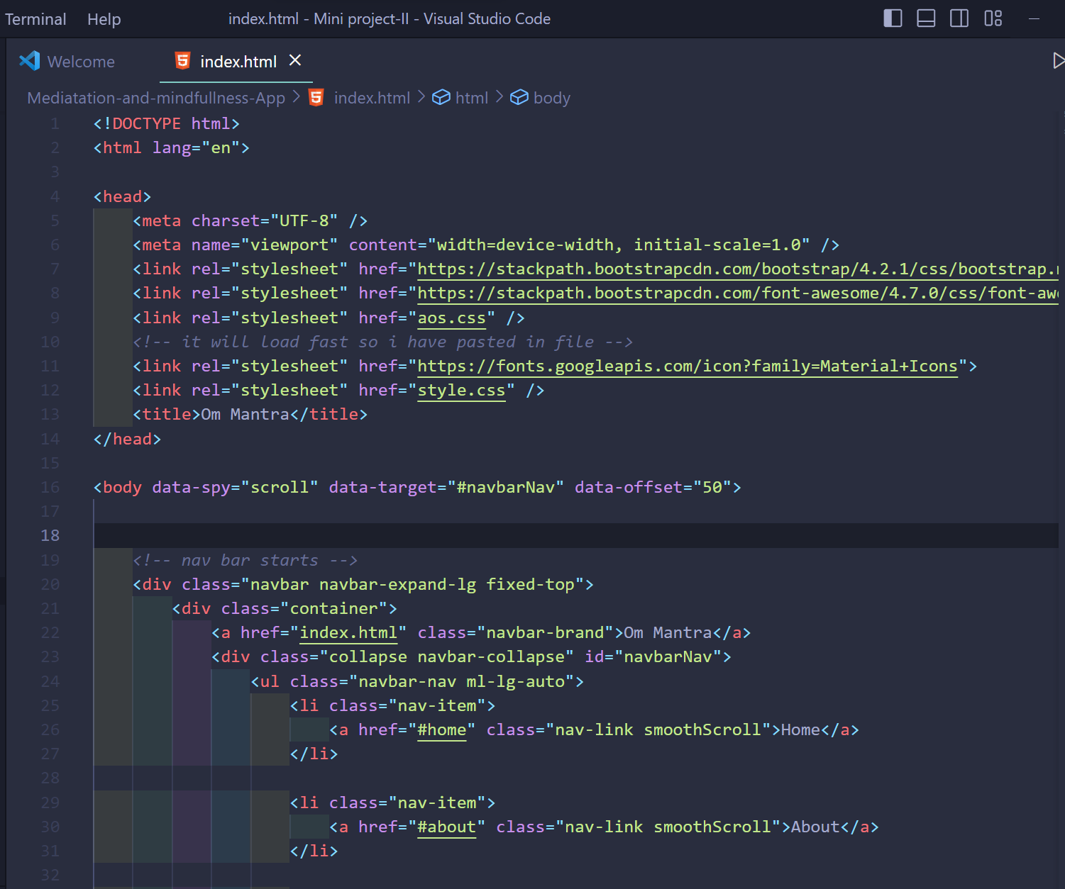

1. **CSS Code:-**

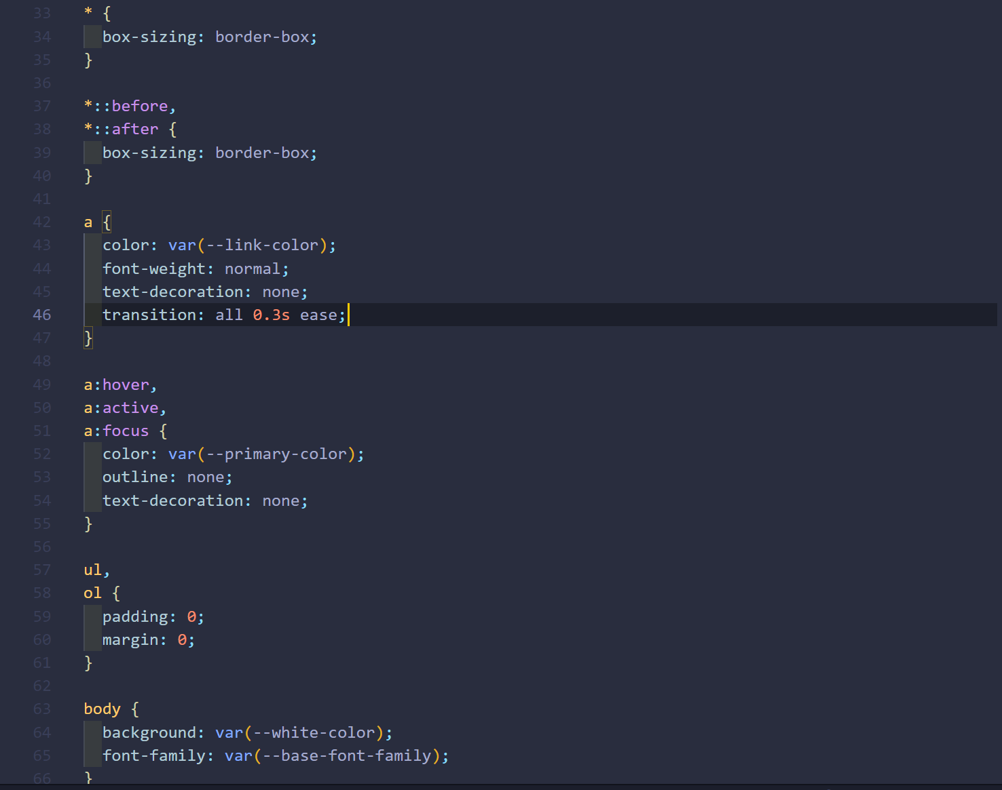

**CSS Code:-**

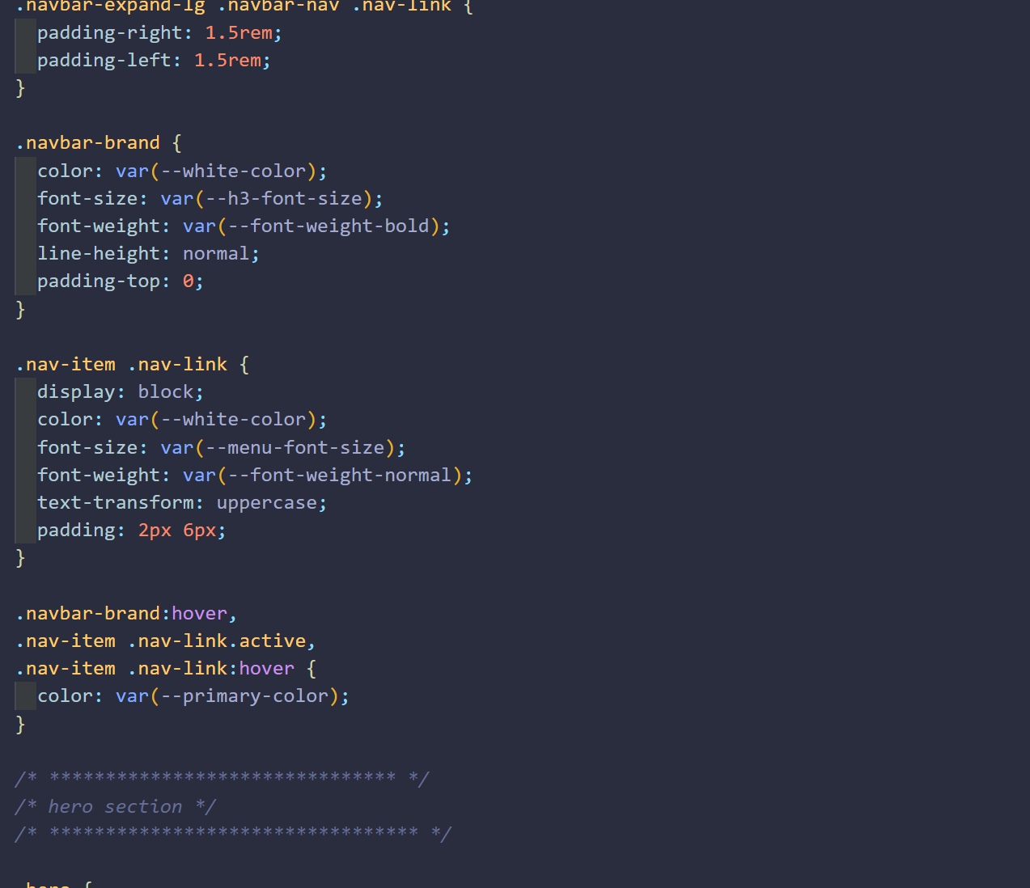

**JavaScript Code :-**

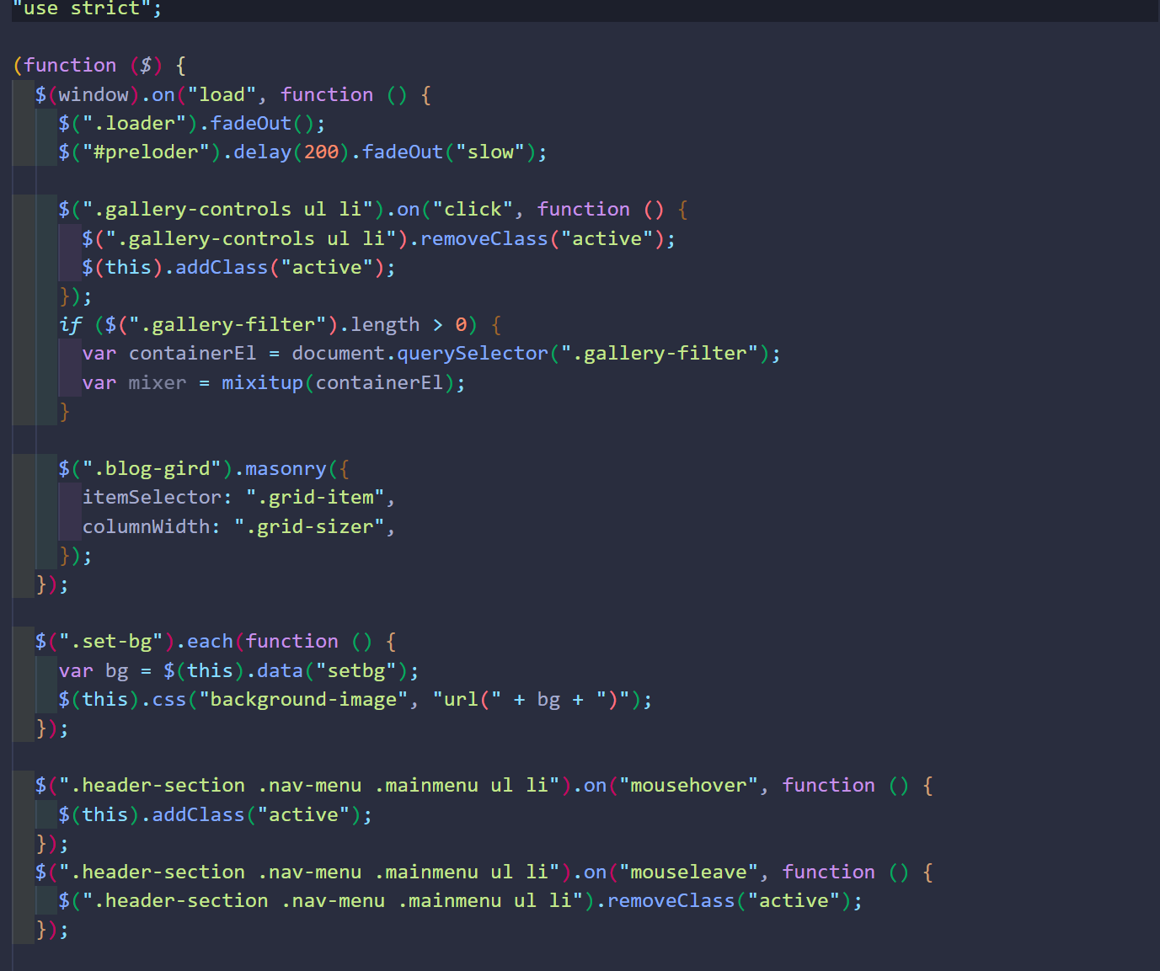

**JavaScript Code :-**

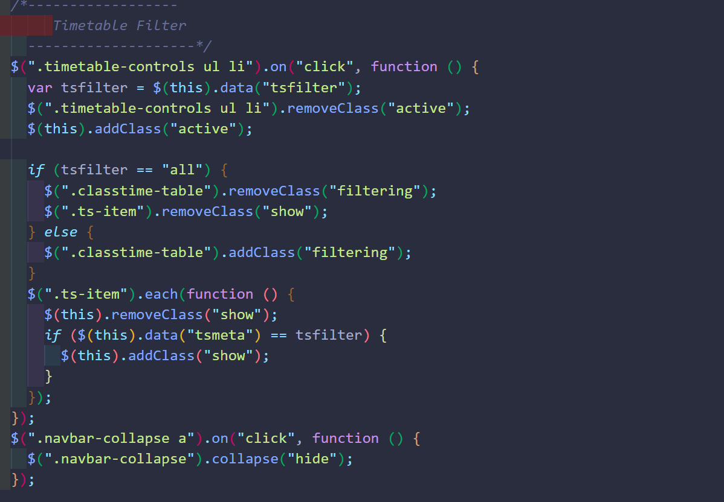

**JavaScript Code :-**

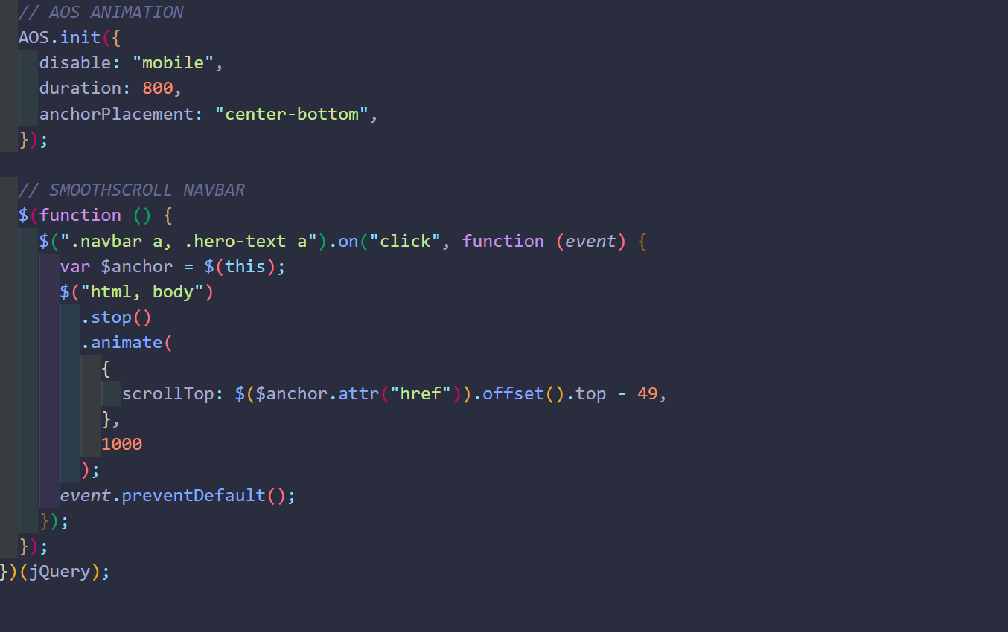

**Result :**

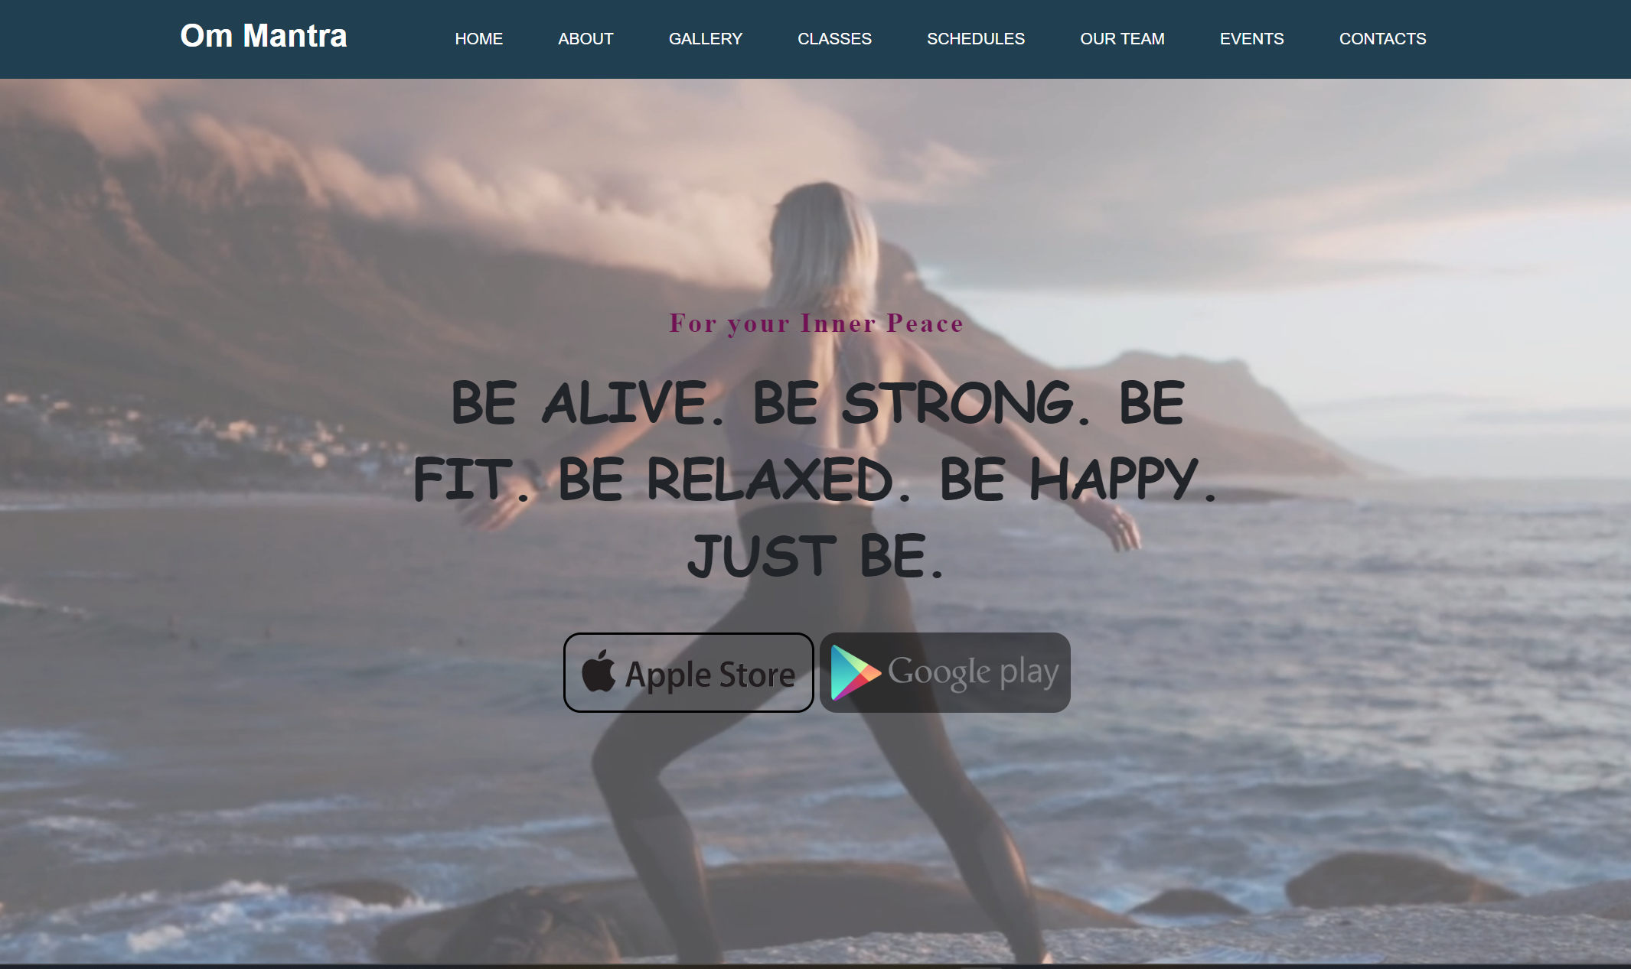

# Conclusion

We have completed our project within time limit with the coordination of our team members under the supervision of our mentor Ms. Gurpreet Kaur

# Github Link:

# <https://github.com/AyushSharma3566/Mediatation-and-mindfullness-App>

# Bibliography

[**www.google.com**](http://www.google.com/)[**www.geeksforgeeks.org**](http://www.geeksforgeeks.org/)[**www.youtube.co**](http://www.youtube.com/)**m**